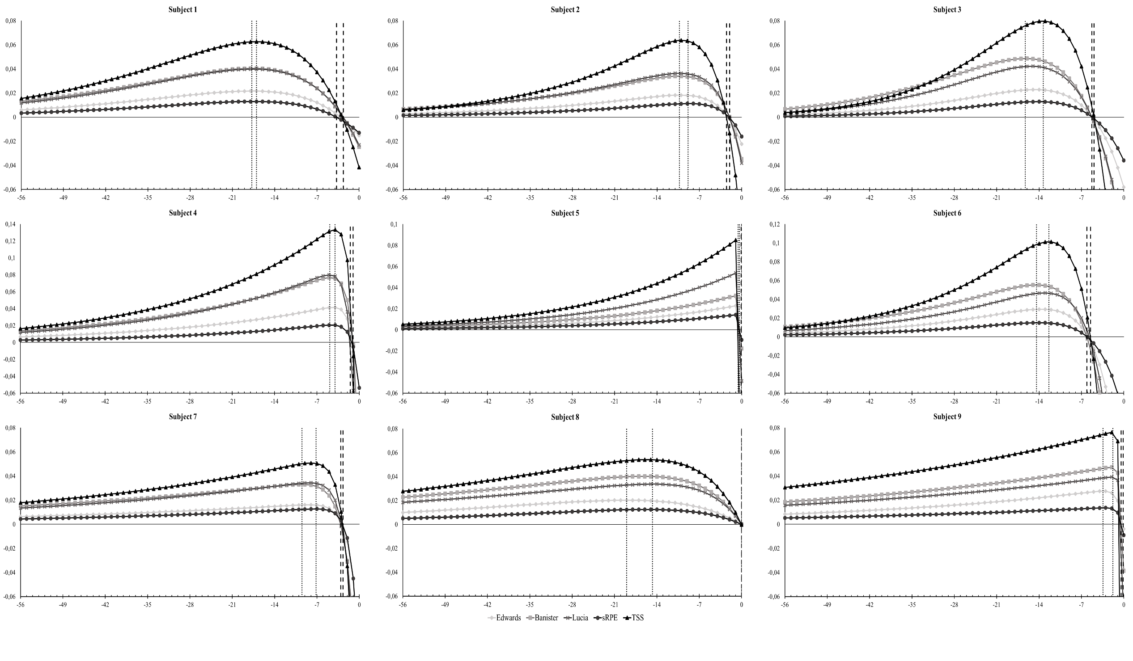

Figure 3: Overview of the influence curves of the subjects according to the TL-method used. On the y-axis the netto influence of a training on the day of performance is given (AU). On the x-axis the days preceding the day of performance are plotted. Vertical dotted lines and dashed lines represent the range of respectively t(g) and t(n) calculated for the different TL-methods.